**1. Multi Tier Web Application Setup - Locally**

The agenda of this Project is to host a [[1.Multi-Tier-Web-Application-Setup---Locally]](https://github.com/technicalhrushi/1.Multi-Tier-Web-Application-Setup---Locally) on my local machine by Automation.

* Project Architecture (Services) :

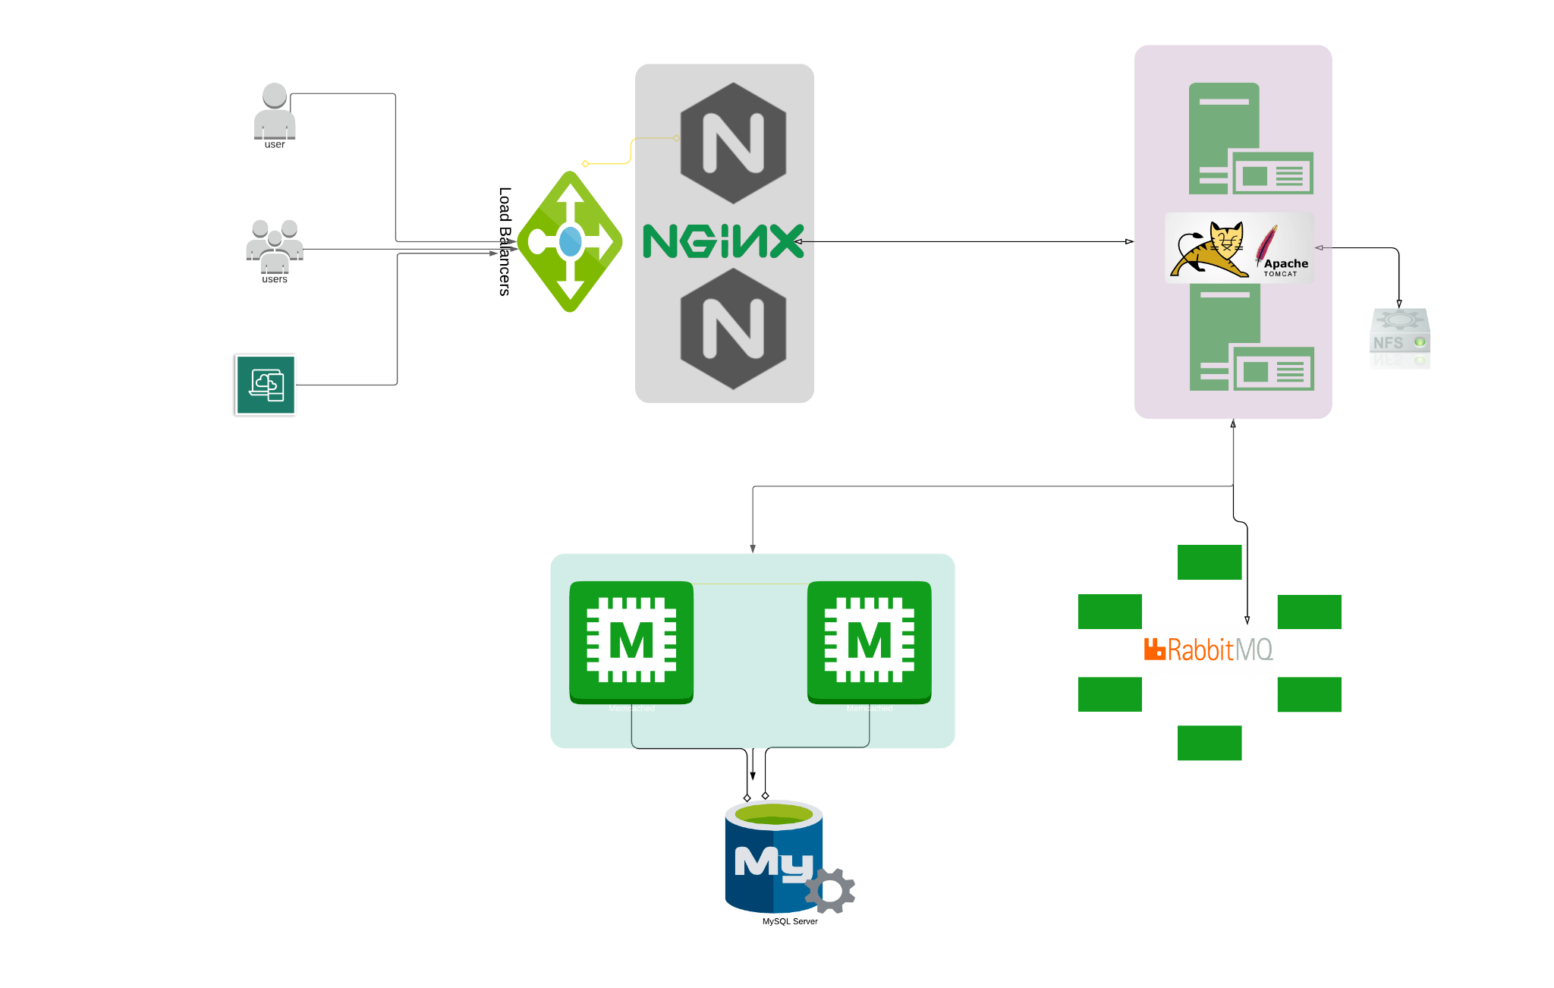

* Project Execution:

I will be using Vagrant & Bash Script to automate the Project.

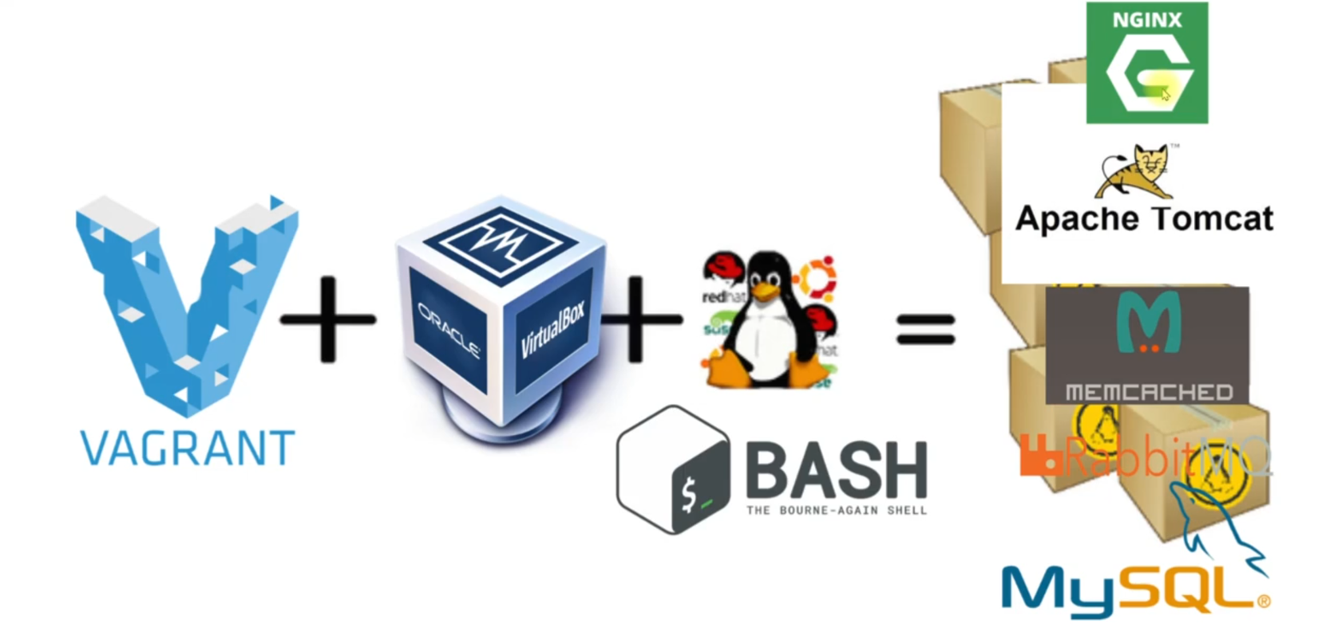

1. Vagrant Setup

* Update the vagrant file
* Add the provision command to execute the bash script

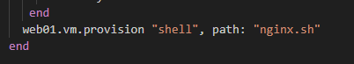

* Place all the bash scripts inside the Vagrant directory itself, next to Vagrant file

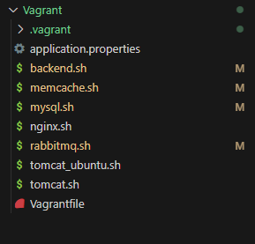

1. Bash Script
2. What is Bash Script

* A bash script is a file containing a sequence of commands that are executed by the bash program line by line. It allows you to perform a series of actions, such as navigating to a specific directory, creating a folder, and launching a process using the command line.

1. How I will be writing the Bash Script?

* I will be adding all the commands which I used to manually install the support software tools in my [[1.Multi-Tier-Web-Application-Setup---Locally]](https://github.com/technicalhrushi/1.Multi-Tier-Web-Application-Setup---Locally) project
* Pointers:

1. It will take about 30-40 min to bring all the server Up & Running
2. We have placed application.properties in our local machine instead of configuring it on app01 machine
3. Incase of any doubts, refer to [[1.Multi-Tier-Web-Application-Setup---Locally]](https://github.com/technicalhrushi/1.Multi-Tier-Web-Application-Setup---Locally) project.